<https://power.larc.nasa.gov/api/temporal/climatology/regional?latitude-min=0&latitude-max=9&longitude-min=110&longitude-max=119&parameters=ALLSKY_SFC_SW_DWN,CLRSKY_SFC_SW_DWN,ALLSKY_SFC_SW_DNI,ALLSKY_SFC_SW_DNI_MAX,ALLSKY_SFC_SW_DNI_MIN,ALLSKY_SFC_SW_DIFF,ALLSKY_SFC_SW_DIFF_MAX,ALLSKY_SFC_SW_DIFF_MIN,ALLSKY_KT,ALLSKY_NKT,CLRSKY_KT,CLRSKY_NKT,SI_EF_TILTED_SURFACE,ALLSKY_SRF_ALB&community=RE&format=CSV&user=DAV>

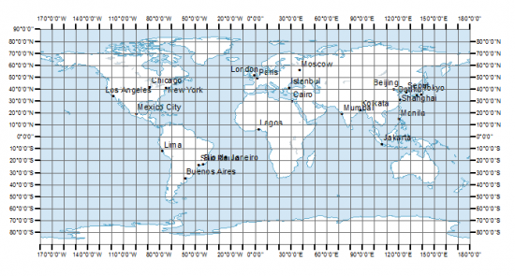

Latitude = -10,0,10,20,30

Longitude = 100,110,120,130,140

A grid of [5x5] to cover South East Asia

Test – Singapore

* Latitude [0,10]
* Longitute [110,120]

<https://power.larc.nasa.gov/api/temporal/monthly/configuration>

|  |
| --- |
| https://power.larc.nasa.gov/api/temporal/monthly/regional?latitude-min=0&latitude-max=9&longitude-min=110&longitude-max=119&parameters= ALLSKY_SFC_SW_DWN&community=SB&start=2016&end=2017&format=CSV&header=false |